If Statements

if (logical test) {
what to do if true
} else {
what to do if false
}
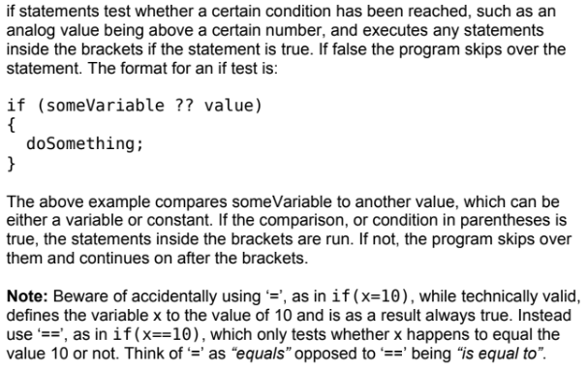
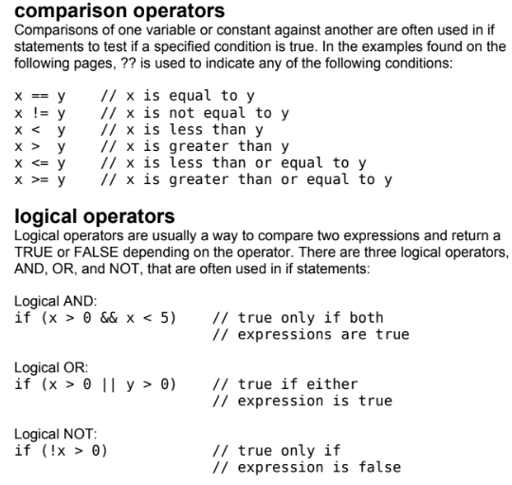
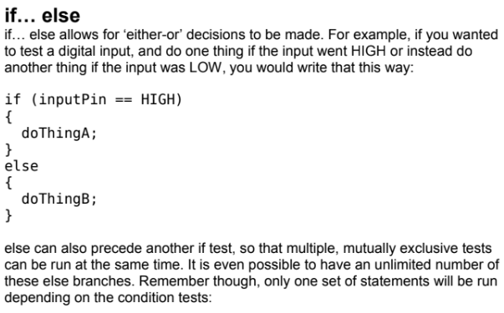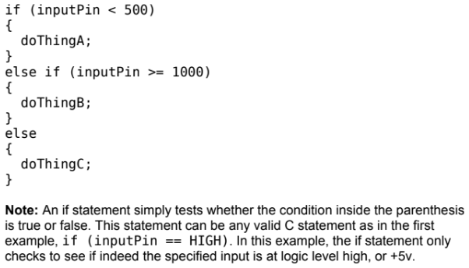

Example 1:

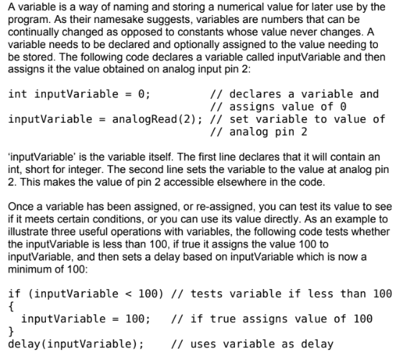

Example 2:

int value=33;
if( value <50){
Serial.print("The value is less than 50");
}
else if (value ==50){
Serial.print("The value is equal to 50");
}
else{
Serial.print("The value is greater than 50");
}

